WEEK ASSIGNMENT -2

1

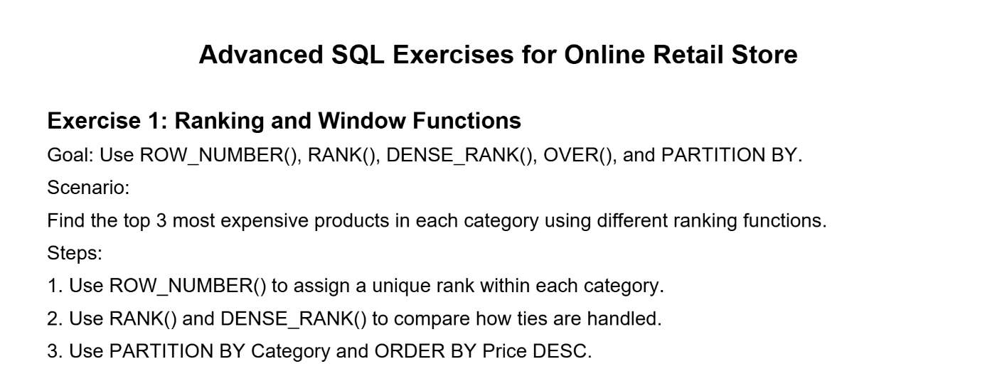

Program:

CREATE DATABASE cognizant_ex1;

use cognizant_ex1;

CREATE TABLE Products (

ProductID INT PRIMARY KEY,

ProductName VARCHAR(100),

Category VARCHAR(50),

Price DECIMAL(10, 2)

);

INSERT INTO Products (ProductID, ProductName, Category, Price) VALUES

-- Electronics

(1, 'Laptop', 'Electronics', 1200.00),

(2, 'Smartphone', 'Electronics', 800.00),

(3, 'Tablet', 'Electronics', 800.00), -- same price as Smartphone

(4, 'Smartwatch', 'Electronics', 500.00),

(5, 'Earbuds', 'Electronics', 200.00),

-- Accessories

(6, 'Backpack', 'Accessories', 100.00),

(7, 'Headphones', 'Accessories', 150.00),

(8, 'Charger', 'Accessories', 50.00),

(9, 'Mouse', 'Accessories', 100.00),

(10, 'Keyboard', 'Accessories', 100.00),

-- Home Appliances

(11, 'Vacuum Cleaner', 'Home Appliances', 300.00),

(12, 'Microwave', 'Home Appliances', 400.00),

(13, 'Refrigerator', 'Home Appliances', 900.00),

(14, 'Blender', 'Home Appliances', 400.00),

(15, 'Air Purifier', 'Home Appliances', 400.00);

SELECT *

FROM (

SELECT

ProductID,

ProductName,

Category,

Price,

ROW_NUMBER() OVER (PARTITION BY Category ORDER BY Price DESC) AS RowNum

FROM Products

) AS ranked

WHERE RowNum <= 3;

SELECT *

FROM (

SELECT

ProductID,

ProductName,

Category,

Price,

RANK() OVER (PARTITION BY Category ORDER BY Price DESC) AS PriceRank

FROM Products

) AS ranked

WHERE PriceRank <= 3;

SELECT *

FROM (

SELECT

ProductID,

ProductName,

Category,

Price,

DENSE_RANK() OVER (PARTITION BY Category ORDER BY Price DESC) AS DensePriceRank

FROM Products

) AS ranked

WHERE DensePriceRank <= 3;

**Output:  
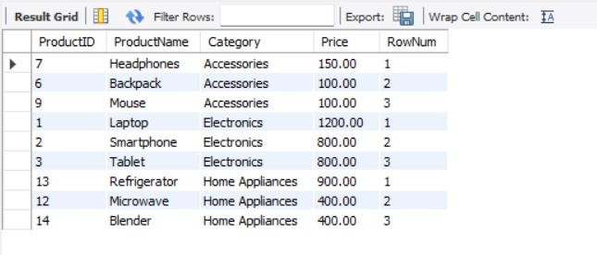  
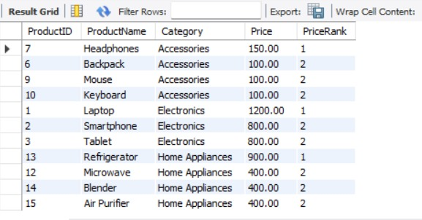  
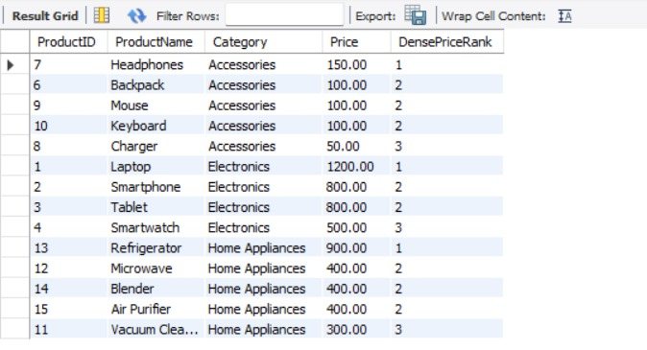**

**2:  
-- Database Schema**

**CREATE TABLE Customers (**

**CustomerID INT PRIMARY KEY,**

**Name VARCHAR(100),**

**Region VARCHAR(50)**

**);**

**CREATE TABLE Products (**

**ProductID INT PRIMARY KEY,**

**ProductName VARCHAR(100),**

**Category VARCHAR(50),**

**Price DECIMAL(10, 2)**

**);**

**CREATE TABLE Orders (**

**OrderID INT PRIMARY KEY,**

**CustomerID INT,**

**OrderDate DATE,**

**FOREIGN KEY (CustomerID) REFERENCES Customers(CustomerID)**

**);**

**CREATE TABLE OrderDetails (**

**OrderDetailID INT PRIMARY KEY,**

**OrderID INT,**

**ProductID INT,**

**Quantity INT,**

**FOREIGN KEY (OrderID) REFERENCES Orders(OrderID),**

**FOREIGN KEY (ProductID) REFERENCES Products(ProductID)**

**);**

**-- Sample Data**

**INSERT INTO Customers (CustomerID, Name, Region) VALUES**

**(1, 'Alice', 'North'),**

**(2, 'Bob', 'South'),**

**(3, 'Charlie', 'East'),**

**(4, 'David', 'West');**

**INSERT INTO Products (ProductID, ProductName, Category, Price) VALUES**

**(1, 'Laptop', 'Electronics', 1200.00),**

**(2, 'Smartphone', 'Electronics', 800.00),**

**(3, 'Tablet', 'Electronics', 600.00),**

**(4, 'Headphones', 'Accessories', 150.00);**

**INSERT INTO Orders (OrderID, CustomerID, OrderDate) VALUES**

**(1, 1, '2023-01-15'),**

**(2, 2, '2023-02-20'),**

**(3, 3, '2023-03-25'),**

**(4, 4, '2023-04-30');**

**INSERT INTO OrderDetails (OrderDetailID, OrderID, ProductID, Quantity) VALUES**

**(1, 1, 1, 1),**

**(2, 2, 2, 2),**

**(3, 3, 3, 1),**

**(4, 4, 4, 3);**

**-- Exercise 1: Creating a Non-Clustered Index**

**-- Goal: Create a non-clustered index on the ProductName column in the Products table and compare query execution time before and after index creation.**

**-- Step 1: Query to fetch product details before index creation**

**SELECT * FROM Products WHERE ProductName = 'Laptop';**

**-- Step 2: Create a non-clustered index on ProductName**

**-- Step 3: Query to fetch product details after index creation**

**SELECT * FROM Products WHERE ProductName = 'Laptop';**

**-- Exercise 2: Creating a Clustered Index**

**-- Goal: Create a clustered index on the OrderDate column in the Orders table and compare query execution time before and after index creation.**

**-- Step 1: Query to fetch orders before index creation**

**SELECT * FROM Orders WHERE OrderDate = '2023-01-15';**

**-- Step 2: Create a clustered index on OrderDate**

**-- Step 3: Query to fetch orders after index creation**

**SELECT * FROM Orders WHERE OrderDate = '2023-01-15';**

**-- Exercise 3: Creating a Composite Index**

**-- Goal: Create a composite index on the CustomerID and OrderDate columns in the Orders table and compare query execution time before and after index creation.**

**-- Step 1: Query to fetch orders before index creation**

**SELECT * FROM Orders WHERE CustomerID = 1 AND OrderDate = '2023-01-15';**

**-- Step 2: Create a composite index on CustomerID and OrderDate**

**-- Step 3: Query to fetch orders after index creation**

**SELECT * FROM Orders WHERE CustomerID = 1 AND OrderDate = '2023-01-15';**

**Program:**

**CREATE DATABASE cognizant_ex2;**

**use cognizant_ex2;**

**CREATE TABLE Customers (**

**CustomerID INT PRIMARY KEY,**

**Name VARCHAR(100),**

**Region VARCHAR(50)**

**);**

**CREATE TABLE Products (**

**ProductID INT PRIMARY KEY,**

**ProductName VARCHAR(100),**

**Category VARCHAR(50),**

**Price DECIMAL(10, 2)**

**);**

**CREATE TABLE Orders (**

**OrderID INT PRIMARY KEY,**

**CustomerID INT,**

**OrderDate DATE,**

**FOREIGN KEY (CustomerID) REFERENCES Customers(CustomerID)**

**);**

**CREATE TABLE OrderDetails (**

**OrderDetailID INT PRIMARY KEY,**

**OrderID INT,**

**ProductID INT,**

**Quantity INT,**

**FOREIGN KEY (OrderID) REFERENCES Orders(OrderID),**

**FOREIGN KEY (ProductID) REFERENCES Products(ProductID)**

**);**

**INSERT INTO Customers (CustomerID, Name, Region) VALUES**

**(1, 'Alice', 'North'),**

**(2, 'Bob', 'South'),**

**(3, 'Charlie', 'East'),**

**(4, 'David', 'West');**

**INSERT INTO Products (ProductID, ProductName, Category, Price) VALUES**

**(1, 'Laptop', 'Electronics', 1200.00),**

**(2, 'Smartphone', 'Electronics', 800.00),**

**(3, 'Tablet', 'Electronics', 600.00),**

**(4, 'Headphones', 'Accessories', 150.00);**

**INSERT INTO Orders (OrderID, CustomerID, OrderDate) VALUES**

**(1, 1, '2023-01-15'),**

**(2, 2, '2023-02-20'),**

**(3, 3, '2023-03-25'),**

**(4, 4, '2023-04-30');**

**INSERT INTO OrderDetails (OrderDetailID, OrderID, ProductID, Quantity) VALUES**

**(1, 1, 1, 1),**

**(2, 2, 2, 2),**

**(3, 3, 3, 1),**

**(4, 4, 4, 3);**

**-- query-ans-1**

**SELECT * FROM Products WHERE ProductName = 'Laptop';**

**CREATE INDEX idx_ProductName ON Products(ProductName);**

**SELECT * FROM Products WHERE ProductName = 'Laptop';**

**EXPLAIN SELECT * FROM Products WHERE ProductName = 'Laptop';**

**-- query-ans-2**

**SELECT * FROM Orders WHERE OrderDate = '2023-01-15';**

**CREATE INDEX idx_OrderDate ON Orders(OrderDate);**

**EXPLAIN SELECT * FROM Orders WHERE OrderDate = '2023-01-15';**

**-- query-ans-3**

**SELECT * FROM Orders WHERE CustomerID = 1 AND OrderDate = '2023-01-15';**

**CREATE INDEX idx_Customer_OrderDate ON Orders(CustomerID, OrderDate);**

**EXPLAIN SELECT * FROM Orders WHERE CustomerID = 1 AND OrderDate = '2023-01-15';**

**Output:**

**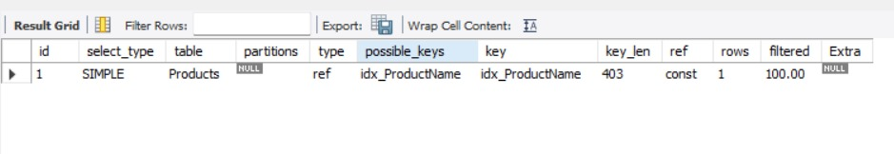  
  
**

**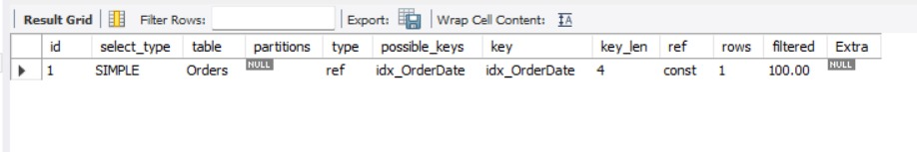  
  
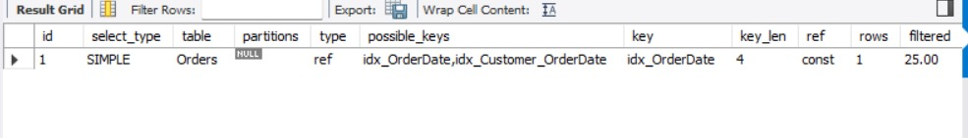**

**3:**

Employee Management System - SQL Exercises Database Schema Departments Table CREATE TABLE Departments ( DepartmentID INT PRIMARY KEY, DepartmentName VARCHAR(100) ); Employees Table CREATE TABLE Employees ( EmployeeID INT PRIMARY KEY, FirstName VARCHAR(50), LastName VARCHAR(50), DepartmentID INT FOREIGN KEY REFERENCES Departments(DepartmentID), Salary DECIMAL(10, 2), JoinDate DATE ); Exercises Exercise 1: Create a Simple View Goal: Create a view to show basic employee details. Task: Create a view named vw_EmployeeBasicInfo that displays EmployeeID, FirstName, LastName, and DepartmentName by joining Employees and Departments. Exercise 2: Add Computed Column - Full Name Goal: Use a computed column in a view. Task: Modify or create a view named vw_EmployeeFullName that includes a computed column FullName (concatenation of FirstName and LastName). Example Computed Column: FirstName + ' ' + LastName AS FullName Exercise 3: Add Computed Column - Annual Salary Goal: Add a financial computed column. Task: Create a view named vw_EmployeeAnnualSalary that includes a computed column AnnualSalary (Salary * 12). Exercise 4: Add Multiple Computed Columns Goal: Combine multiple computed columns in a single view. Task: Create a view named vw_EmployeeReport that includes: - EmployeeID - FullName - DepartmentName - AnnualSalary - Bonus (10% of AnnualSalary) Example Bonus Calculation: (Salary * 12) * 0.10 AS Bonus

**Program;  
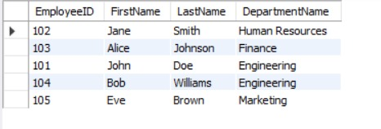  
  
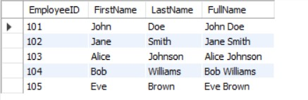  
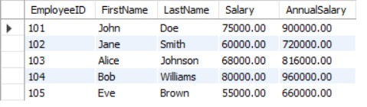  
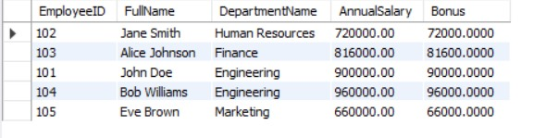  
4:  
Objectives:**

**· Understand how Mocking can enhance Test-Driven Development (TDD)**

**o Mocking, Isolation, Test doubles, Mock Vs Fake Vs Stub, Key advantages of TDD**

**· Explain the meaning of Mocking in Unit Testing and why use mocks in Unit Testing**

**o Mocking and Isolation in Unit Testing, Isolating dependencies in Tests using Mocks and Stubs**

**· Understand the basics of DI (Dependency Injection) and how dependency injection helps unit testing in applications**

**o Dependency Injection, Constructor Injection, Method Injection**

**· Demonstrate on how to create a testable code with Moq.**

**o Testable code**

**· Demonstrate on how to create a mock object that access database for unit tests**

**o Mock database for Unit Tests**

**· Demonstrate on mock object that access the file system for unit tests**

**o Mock files for Unit Tests**

**1. Write Testable Code with Moq**

## **Scenario**

**You are tasked to write a unit test code for the below scenario.**

**The application in which you are teamed up with, deals with a mail server communication in which your application tries to send mail to its users upon every transaction. Your role is to write unit testing the module that contains send mail functionality. You wanted to perform testing the module without sending any email.**

**After investigating the problem scenario, you found a solution and that is creating mock objects of these external dependencies in the unit testing project so that you can achieve speedier test execution and loose coupling of code.**

**Note: Duration to complete this exercise is 30 min.**

## **Task1**

**In this task, you will create a class library that will be used for unit testing.**

**· Create a Class Library (Language C#) project using Visual Studio IDE, and name it as CustomerCommLib.**

**· Rename the default Class1 class name as MailSender.**

**· Include the following namespaces with ‘using’ directive.**

**o System.Net**

**o System.Net.Mail**

**· Define an interface as follow.**

**public interface IMailSender**

**{**

**bool SendMail(string toAddress, string message);**

**}**

**· And provide implementation of IMailSender in the MailSender class as seen below.**

**namespace CustomerCommLib**

**{**

**public class MailSender:IMailSender**

**{**

**public bool SendMail(string toAddress, string message)**

**{**

**MailMessage mail = new MailMessage();**

**SmtpClient SmtpServer = new SmtpClient("smtp.gmail.com");**

**mail.From = new MailAddress("your_email_address@gmail.com");**

**mail.To.Add(toAddress);**

**mail.Subject = "Test Mail";**

**mail.Body = message;**

**SmtpServer.Port = 587;**

**SmtpServer.Credentials = new NetworkCredential("username", "password");**

**SmtpServer.EnableSsl = true;**

**SmtpServer.Send(mail);**

**}**

**}**

**}**

**The above class can’t be unit testing since the code access the STMP mail server.**

**· Create another class called CustomeComm which is the class under test in the given scenario.**

**namespace CustomerCommLib**

**{**

**public class CustomerComm**

**{**

**IMailSender _mailSender;**

**public CustomerComm(IMailSender mailSender)**

**{**

**_mailSender=mailSender;**

**}**

**public bool SendMailToCustomer()**

**{**

**//Actual logic goes here**

**//define message and mail address**

**_mailSender.SendMail(cust123@abc.com,”Some Message”);**

**return true;**

**}**

**}**

**}**

**In the above code we injected the dependency (IMailSender) through constructor of CustomerComm class so that we can pass the mock object of the dependency wherever it is necessary.**

**We have successfully created a class that's written in such a way that we can run a unit test against it and an exception won't be thrown. We achieve this by mocking the call to IMailSender.SendMail() and adding a mocked return value of true to it.**

**· Finally build your project and be ready for the unit testing with NUnit and Moq.**

## **Task2**

**In this task, you will create unit test project which make use of NUnit framework and Moq.**

**· Create a new class library project called CustomerComm.Tests and add the following external dependencies to it using NuGet Package Manager.**

**o NUnit**

**o NUnit Test Adapter**

**o Moq**

**· Add the references of assemblies as appropriate including CustomerCommLib.**

**· Write unit test code and mock the MailSender (IMailSender) class.**

**· Use TestFixture, OneTimeSetUp and TestCase attribute classes on top of test class, init method and test method respectively.**

**· Configure the mock object in such away that SendMail() method will accept any two string arguments and always return true when SendMailToCustomer() gets invoked.**

**· Finally assert the return value to “true”.**

**2. Mock file object for Unit Tests**

## **Scenario**

**You are tasked to write a unit test code for the below scenario.**

**The application in which you are teamed up with, deals with the file system and it searches for files and retrieves files under the specified path. In the existing system, Directory.GetFiles() method has been used. You found that it’s not good idea to use Directory.GetFiles from the System.IO being its static and unable to unit test such methods.**

**After investigating the problem scenario, you found a solution and that is refactoring the code. Instead of using directly the static method Directory.GetFiles, you decided to create your own implementation to the method so that be able to mock files in the Unit Tests.**

**Note: Duration to complete this exercise is 30 min.**

## **Task1**

**· Create a Class Library (Language C#) project using Visual Studio IDE, and name it as MagicFilesLib.**

**· Rename the default Class1 class name as DirectoryExplorer and include the following code snippet into it.**

**· Include the following namespaces with ‘using’ directive.**

**o System.Collections.Generic**

**o System.IO**

**· Define an interface as follow.**

**public interface IDirectoryExplorer**

**{**

**ICollection<string> GetFiles(string path);**

**}**

**· And provide implementation of IDirectoryExplorer in the DirectoryExplorer class as seen below.**

**namespace MagicFilesLib**

**{**

**public class DirectoryExplorer: IDirectoryExplorer**

**{**

**public ICollection<string> GetFiles(string path)**

**{**

**string[] files = Directory.GetFiles(path);**

**return files;**

**}**

**}**

**}**

**Finally build your project and be ready for the unit testing with NUnit and Moq.**

## **Task2**

**· Create a new class library project called DirectoryExplorer.Tests and add the following external dependencies to it using NuGet Package Manager.**

**o NUnit**

**o NUnit Test Adapter**

**o Moq**

**· Add the references of assemblies as appropriate including MagicFilesLib.**

**· Write unit test code and mock the DirectoryExplorer (IDirectoryExplorer), which is the class under test, with some hard coded file names.**

**· Use TestFixture, OneTimeSetUp and TestCase attribute classes on top of test class, init method and test method respectively.**

**· Add the following declarations in the test class.**

**private readonly string _file1 = "file.txt";**

**private readonly string _file2 = "file2.txt";**

**· In the test method, assert the following so that,**

***the collection is not null***

***the collection count is equal to 2***

***the collection contains _file1***

**3. Mock database for Unit Tests**

## **Scenario**

**You are tasked to write a unit test code for the below scenario.**

**The application in which you are teamed up with, deals with a network database in which your application stores the record or certain players. It involves storing and retrieval of player details. Your role is to write unit testing the player module which involves an external dependency. You can’t proceed with unit testing.**

**After investigating the problem scenario, you found a solution and that is creating mock objects of these external dependencies in the unit testing project so that you can achieve speedier test execution and loose coupling of code.**

**Note: Duration to complete this exercise is 60 min.**

## **Task1**

**In this task, you will create a class library that will be used for unit testing.**

**· Create a Class Library (Language C#) project using Visual Studio IDE, and name it as PlayersManagerLib.**

**· Rename the default Class1 class name as PlayerManager.**

**· Include the following namespaces with ‘using’ directive.**

**o System.Data**

**o System.Data.SqlClient**

**· Define an interface as follow.**

**public interface IPlayerMapper**

**{**

**bool IsPlayerNameExistsInDb(string name);**

**Void AddNewPlayerIntoDb(string name);**

**}**

**· And provide implementation of IPlayerMapper in the PlayerMapper class as seen below.**

**namespace PlayersManagerLib**

**{**

**public class PlayerMapper: IPlayerMapper**

**{**

**private readonly string _connectionString =**

**"Data Source=(local);Initial Catalog=GameDB;Integrated Security=True";**

**public bool IsPlayerNameExistsInDb(string name)**

**{**

**using(SqlConnection connection = new SqlConnection(_connectionString))**

**{**

**connection.Open();**

**using(SqlCommand command = connection.CreateCommand())**

**{**

**command.CommandText = "SELECT count(*) FROM Player WHERE 'Name' = @name";**

**command.Parameters.AddWithValue("@name", name);**

**// Get the number of player with this name**

**var existingPlayersCount = (int) command.ExecuteScalar();**

**// Result is 0, if no player exists, or 1, if a player already exists**

**return existingPlayersCount > 0;**

**}**

**}**

**}**

**public void AddNewPlayerIntoDb(string name)**

**{**

**using(SqlConnection connection = new SqlConnection(_connectionString))**

**{**

**connection.Open();**

**using(SqlCommand command = connection.CreateCommand())**

**{**

**command.CommandText = "INSERT INTO Player ([Name]) VALUES (@name)";**

**command.Parameters.AddWithValue("@name", name);**

**command.ExecuteNonQuery();**

**}**

**}**

**}**

**}**

**}**

**The above class can’t be unit testing since the code access the database.**

**· Create another class called Player and add the following codes.**

**public class Player**

**{**

**public string Name { get; private set; }**

**public int Age { get; private set; }**

**public string Country { get; private set; }**

**public int NoOfMatches {get; private set;}**

**public Player(string name, int age, string country, int noOfMatches)**

**{**

**Name = name;**

**Age=age;**

**Country= country;**

**NoOfMatches = noOfMatches;**

**}**

**public static Player RegisterNewPlayer(string name, IPlayerMapper playerMapper = null)**

**{**

**// If a PlayerMapper was not passed in, use a real one.**

**// This allows us to pass in a "mock" PlayerMapper (for testing),**

**// but use a real PlayerMapper, when running the program.**

**if(playerMapper == null)**

**{**

**playerMapper = new PlayerMapper();**

**}**

**if(string.IsNullOrWhiteSpace(name))**

**{**

**throw new ArgumentException("Player name can’t be empty.");**

**}**

**// Throw an exception if there is already a player with this name in the database.**

**if(playerMapper.IsPlayerNameExistsInDb (name))**

**{**

**throw new ArgumentException("Player name already exists.");**

**}**

**// Add the player to the database.**

**playerMapper. AddNewPlayerIntoDb (name);**

**return new Player(name, 23, “India”,30);**

**}**

**}**

**Finally build your project and be ready for the unit testing with NUnit and Moq.**

## **Task2**

**In this task, you will create unit test project which make use of NUnit framework and Moq.**

**· Create a new class library project called PlayerManager.Tests and add the following external dependencies to it using NuGet Package Manager.**

**o NUnit**

**o NUnit Test Adapter**

**o Moq**

**· Add the references of assemblies as appropriate including PlayersManagerLib.**

**· Write unit test code and mock the PlayerMapper (IPlayerMapper) class.**

**· Use TestFixture, OneTimeSetUp and TestCase attribute classes on top of test class, init method and test method respectively.**

**· Use ExpectedException attribute to specify that the execution of a test will throw an exception.**

**· When the RegisterNewPlayer function calls IsPlayerNameExistsInDb, you need to make sure that the mock object to return “false”.**

**· In the test method, assert various player attributes.**

**Program  
[MailSender.cs](http://mailsender.cs):**using System.Net;

using System.Net.Mail;

namespace CustomerCommLib

{

public interface IMailSender

{

bool SendMail(string toAddress, string message);

}

public class MailSender : IMailSender

{

public bool SendMail(string toAddress, string message)

{

MailMessage mail = new MailMessage();

SmtpClient SmtpServer = new SmtpClient("smtp.gmail.com");

mail.From = new MailAddress("your_email_address@gmail.com");

mail.To.Add(toAddress);

mail.Subject = "Test Mail";

mail.Body = message;

SmtpServer.Port = 587;

SmtpServer.Credentials = new NetworkCredential("username", "password");

SmtpServer.EnableSsl = true;

SmtpServer.Send(mail);

return true; // Add return statement

}

}

}

**[CustomerComm.cs](http://customercomm.cs):**namespace CustomerCommLib

{

public class CustomerComm

{

IMailSender _mailSender;

public CustomerComm(IMailSender mailSender)

{

_mailSender = mailSender;

}

public bool SendMailToCustomer()

{

// Actual logic goes here

// define message and mail address

_mailSender.SendMail("cust123@abc.com", "Some Message");

return true;

}

}

}

**[CustomerCommTests.cs](http://customercommtests.cs):**using NUnit.Framework;

using Moq;

using CustomerCommLib;

namespace CustomerComm.Tests

{

[TestFixture]

public class CustomerCommTests

{

private Mock<IMailSender> _mockMailSender;

private CustomerCommLib.CustomerComm _customerComm;

[OneTimeSetUp]

public void Setup()

{

_mockMailSender = new Mock<IMailSender>();

_customerComm = new CustomerCommLib.CustomerComm(_mockMailSender.Object);

}

[TestCase]

public void SendMailToCustomer_ShouldReturnTrue()

{

// Arrange

_mockMailSender.Setup(x => x.SendMail(It.IsAny<string>(), It.IsAny<string>()))

.Returns(true);

// Act

bool result = _customerComm.SendMailToCustomer();

// Assert

Assert.IsTrue(result);

_mockMailSender.Verify(x => x.SendMail(It.IsAny<string>(), It.IsAny<string>()), Times.Once);

}

}

}

**[DirectoryExplorer.cs](http://directoryexplorer.cs)**:  
using System.Collections.Generic;

using System.IO;

namespace MagicFilesLib

{

public interface IDirectoryExplorer

{

ICollection<string> GetFiles(string path);

}

public class DirectoryExplorer : IDirectoryExplorer

{

public ICollection<string> GetFiles(string path)

{

string[] files = Directory.GetFiles(path);

return files;

}

}

}

**[DirectoryExplorerTests.cs](http://directoryexplorertests.cs):**using NUnit.Framework;

using Moq;

using MagicFilesLib;

using System.Collections.Generic;

namespace DirectoryExplorer.Tests

{

[TestFixture]

public class DirectoryExplorerTests

{

private readonly string _file1 = "file.txt";

private readonly string _file2 = "file2.txt";

private Mock<IDirectoryExplorer> _mockDirectoryExplorer;

[OneTimeSetUp]

public void Setup()

{

_mockDirectoryExplorer = new Mock<IDirectoryExplorer>();

}

[TestCase]

public void GetFiles_ShouldReturnMockedFiles()

{

// Arrange

var expectedFiles = new List<string> { _file1, _file2 };

_mockDirectoryExplorer.Setup(x => x.GetFiles(It.IsAny<string>()))

.Returns(expectedFiles);

// Act

var result = _mockDirectoryExplorer.Object.GetFiles("C:\\test");

// Assert

Assert.IsNotNull(result);

Assert.AreEqual(2, result.Count);

Assert.IsTrue(result.Contains(_file1));

Assert.IsTrue(result.Contains(_file2));

}

}

}  
**[PlayerManager.cs](http://playermanager.cs)**:

using System;

using System.Data.SqlClient;

namespace PlayersManagerLib

{

public interface IPlayerMapper

{

bool IsPlayerNameExistsInDb(string name);

void AddNewPlayerIntoDb(string name);

}

public class PlayerMapper : IPlayerMapper

{

private readonly string _connectionString =

"Data Source=(local);Initial Catalog=GameDB;Integrated Security=True";

public bool IsPlayerNameExistsInDb(string name)

{

using (SqlConnection connection = new SqlConnection(_connectionString))

{

connection.Open();

using (SqlCommand command = connection.CreateCommand())

{

command.CommandText = "SELECT count(*) FROM Player WHERE [Name] = @name";

command.Parameters.AddWithValue("@name", name);

var existingPlayersCount = (int)command.ExecuteScalar();

return existingPlayersCount > 0;

}

}

}

public void AddNewPlayerIntoDb(string name)

{

using (SqlConnection connection = new SqlConnection(_connectionString))

{

connection.Open();

using (SqlCommand command = connection.CreateCommand())

{

command.CommandText = "INSERT INTO Player ([Name]) VALUES (@name)";

command.Parameters.AddWithValue("@name", name);

command.ExecuteNonQuery();

}

}

}

}

public class Player

{

public string Name { get; private set; }

public int Age { get; private set; }

public string Country { get; private set; }

public int NoOfMatches { get; private set; }

public Player(string name, int age, string country, int noOfMatches)

{

Name = name;

Age = age;

Country = country;

NoOfMatches = noOfMatches;

}

public static Player RegisterNewPlayer(string name, IPlayerMapper playerMapper = null)

{

if (playerMapper == null)

{

playerMapper = new PlayerMapper();

}

if (string.IsNullOrWhiteSpace(name))

{

throw new ArgumentException("Player name can't be empty.");

}

if (playerMapper.IsPlayerNameExistsInDb(name))

{

throw new ArgumentException("Player name already exists.");

}

playerMapper.AddNewPlayerIntoDb(name);

return new Player(name, 23, "India", 30);

}

}

**}**

**[PlayerManagerTests.cs](http://playermanagertests.cs):**

using NUnit.Framework;

using Moq;

using PlayersManagerLib;

using System;

namespace PlayerManager.Tests

{

[TestFixture]

public class PlayerManagerTests

{

private Mock<IPlayerMapper> _mockPlayerMapper;

[OneTimeSetUp]

public void Setup()

{

_mockPlayerMapper = new Mock<IPlayerMapper>();

}

[TestCase]

public void RegisterNewPlayer_ValidName_ShouldReturnNewPlayer()

{

// Arrange

string playerName = "John Doe";

_mockPlayerMapper.Setup(x => x.IsPlayerNameExistsInDb(playerName))

.Returns(false);

// Act

Player result = Player.RegisterNewPlayer(playerName, _mockPlayerMapper.Object);

// Assert

Assert.IsNotNull(result);

Assert.AreEqual(playerName, result.Name);

Assert.AreEqual(23, result.Age);

Assert.AreEqual("India", result.Country);

Assert.AreEqual(30, result.NoOfMatches);

_mockPlayerMapper.Verify(x => x.AddNewPlayerIntoDb(playerName), Times.Once);

}

[TestCase]

public void RegisterNewPlayer_ExistingName_ShouldThrowException()

{

// Arrange

string playerName = "Existing Player";

_mockPlayerMapper.Setup(x => x.IsPlayerNameExistsInDb(playerName))

.Returns(true);

// Act & Assert

Assert.Throws<ArgumentException>(() =>

Player.RegisterNewPlayer(playerName, _mockPlayerMapper.Object));

}

[TestCase]

public void RegisterNewPlayer_EmptyName_ShouldThrowException()

{

// Act & Assert

Assert.Throws<ArgumentException>(() =>

Player.RegisterNewPlayer("", _mockPlayerMapper.Object));

}

}

}  
 **Output:**

